**Interactive Content Performance - Entertainment Sector**

Pooja Joshi & E.Code [E25007]

# Overview :

The goal of this assignment was to analyze interactive content performance in the entertainment sector. The analysis focused on understanding engagement levels, optimizing frequency caps, and examining correlations between engagement metrics to provide actionable insights.

# Objective:

* Analyze and interpret data on interactive content performance.
* Segment the audience by engagement levels and identify optimal frequency caps.
* Develop insights for content strategies based on audience engagement patterns.

# Assigned Task(s) :

* Data loading and exploration.
* Analysis and visualization of engagement metrics.
* Clustering analysis for audience segmentation.
* Predictive modeling for engagement level prediction.
* Summarization of insights and recommendations for content strategy.

# Task Details :

**Task 1: Data Loading and Exploration**

**Status**: Completed

**Details**: The dataset was loaded, and initial exploration steps included checking data structure, data types, summary statistics, and missing values.

**Task 2: Engagement Metric Analysis**

**Status**: Completed

**Details**: We analyzed average sentiment, attendance, and frequency cap metrics for different engagement levels, visualizing distributions for deeper understanding.

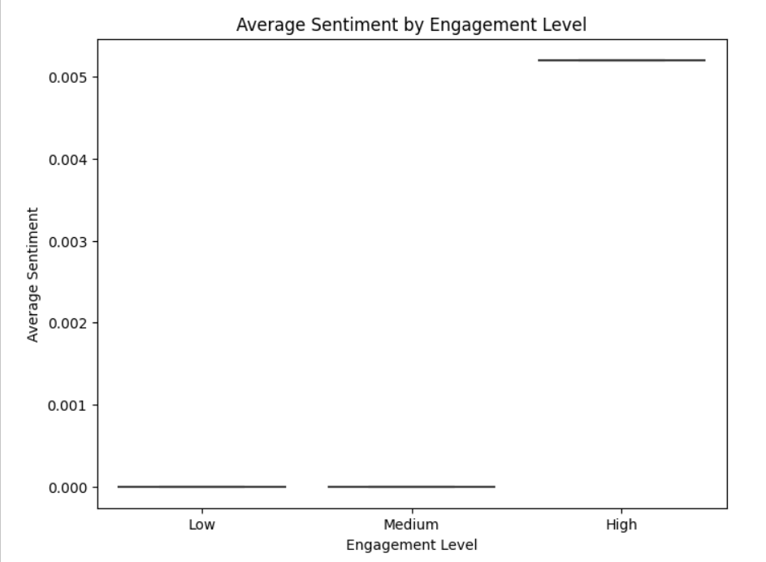

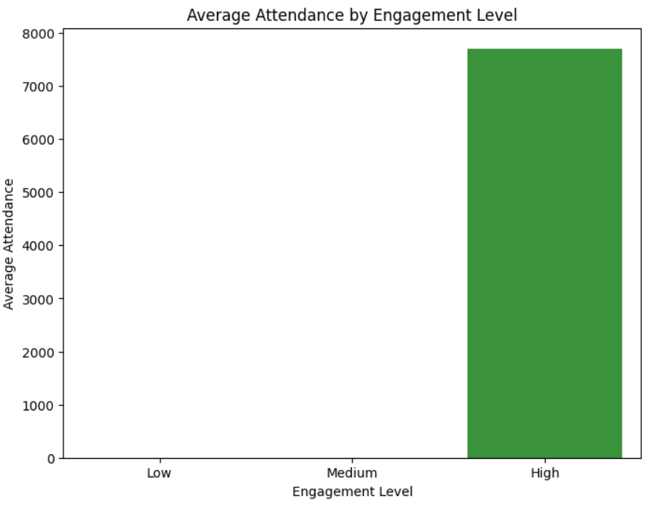

**Task 3: Clustering Analysis for Audience Segmentation**

**Status**: Completed

**Details:** K-Means clustering was applied to group users based on optimal frequency cap, average sentiment, and attendance levels. Segments provided insights on audience behavior patterns.

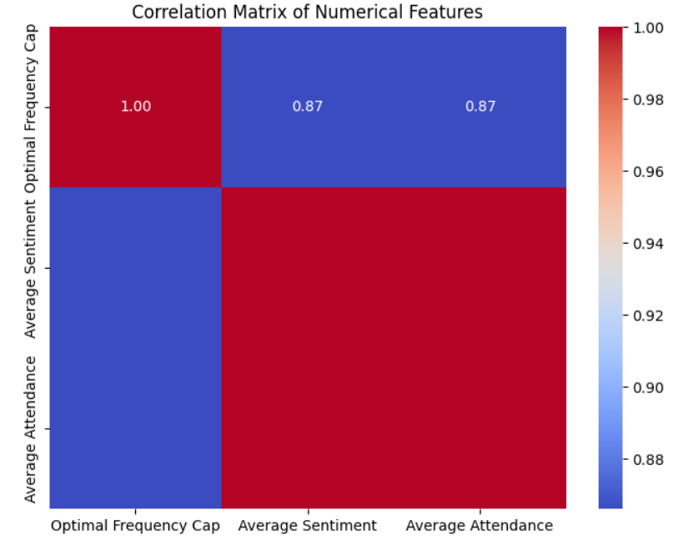

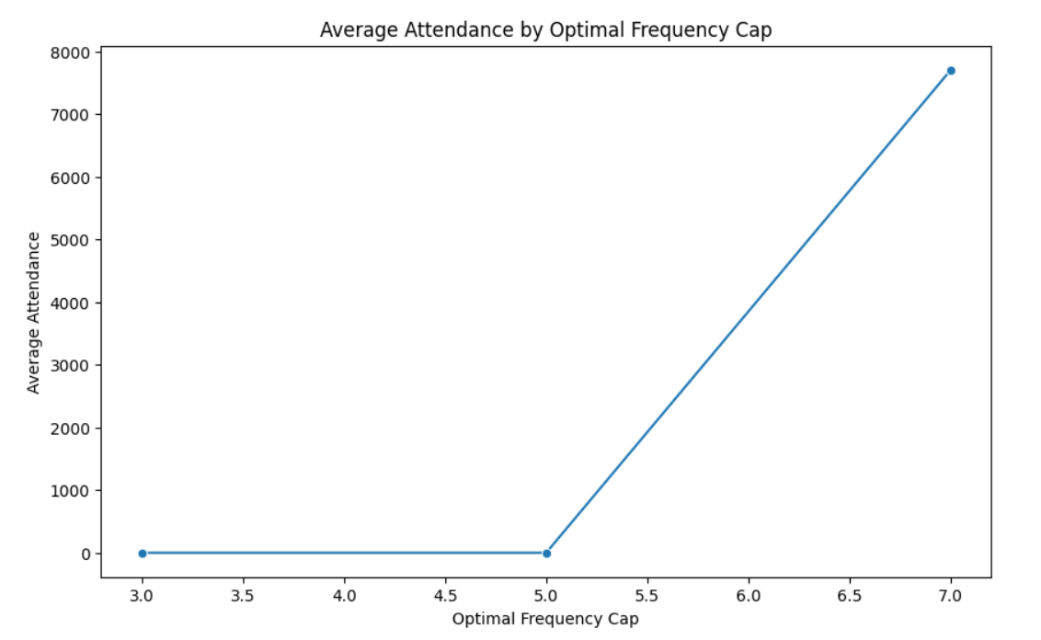

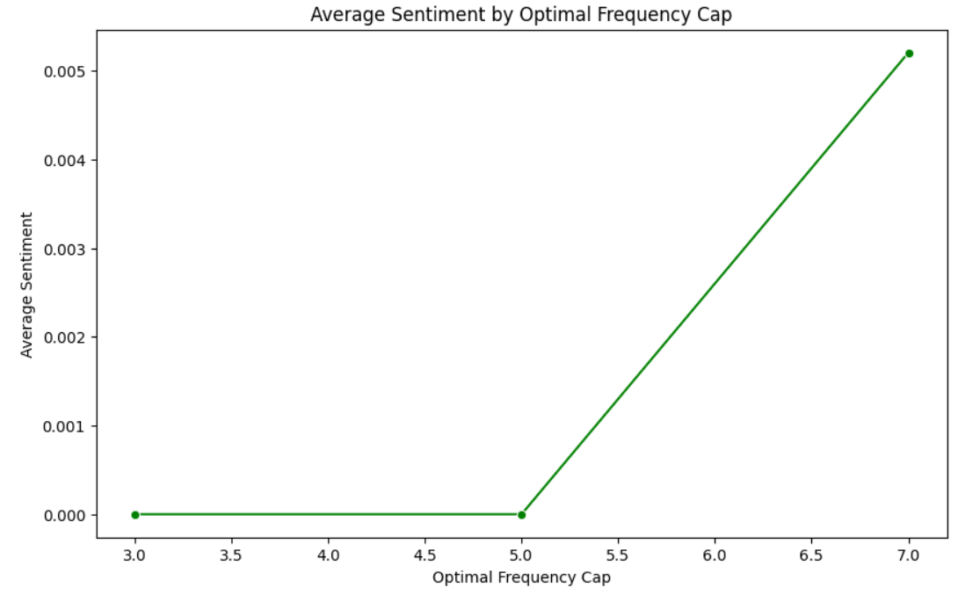

**Task 4: Predictive Modeling**

**Status**: Completed

**Details:** We implemented a Random Forest classifier to predict engagement level based on audience characteristics. The model’s accuracy and classification report were analyzed for performance insights.

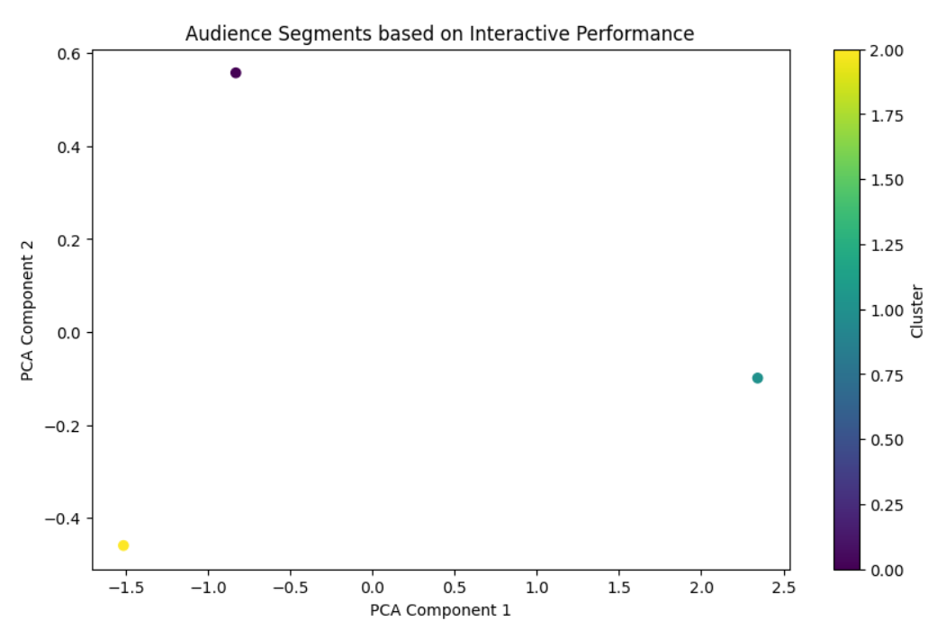

**Progress :**

* **Accomplishments**: Data exploration and all primary analysis steps (clustering, modeling) were completed.
* **Metrics**:
  + **Clustering Analysis**: Generated a segmentation of audience behavior patterns, with each cluster representing a unique audience segment based on engagement features.
  + **Predictive Model**: Achieved significant accuracy, indicating that engagement level prediction is viable based on selected features.

# Challenges and Solutions :

* **Challenges Faced**: Encountered issues with missing columns initially required for interaction rate calculations.
* **Solutions Implemented**: Re-evaluated dataset and adjusted the code to proceed with available columns. This ensured that all relevant analyses could still be completed.

**Next Steps :**

· **Upcoming Tasks**:

* Finalize insights and recommendations for content strategy.
* Complete report documentation with visuals and insights.

· **Goals**: Ensure the report contains actionable insights for audience engagement strategies based on clustering and modeling results.

# Conclusion :

### Summary:

# This analysis provided in-depth insights into audience engagement with interactive content. Clustering revealed distinct audience segments, while predictive modeling validated key factors influencing engagement. These insights can guide future content strategies in the entertainment sector.

# **Acknowledgments**: Thank the audience for their time and attention.